2.48: a) From Eq. (2.8), solving for t gives (40.0 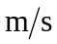 – 20.0 )/9.80 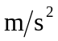 = 2.04 s.
b) Again from Eq. (2.8),

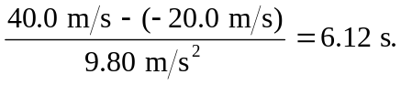

c) The displacement will be zero when the ball has returned to its original vertical position, with velocity opposite to the original velocity. From Eq. (2.8),

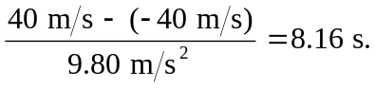

(This ignores the t = 0 solution.)
d) Again from Eq. (2.8), (40 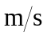)/(9.80 ) = 4.08 s. This is, of course, half the time found in part (c).
e) 9.80 , down, in all cases.
f)
